December 17, 2014 4:110-AP3

Operational Services

Administrative Procedure - School Bus Safety Rules
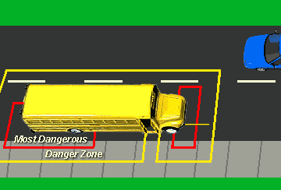
The Building Principal shall distribute the following rules to all students. Those students not qualifying for school bus transportation to and from school should receive a copy because they may from time-to-time be transported to school activities by school bus.
- Dress properly for the weather. Make sure all drawstrings, ties, straps, etc. on all clothing, backpacks and other items, are shortened or removed to lessen the likelihood of them getting caught in bus doors, railings or aisles.
- Arrive on time at the bus stop, and stay away from the street while waiting for the bus.
- Stay away from the bus until it stops completely and the driver signals you to board. Enter in single file without pushing. Always use the handrail.
- Take a seat right away and remain seated facing forward. Keep your hands, arms, and head inside the bus.
- Talk quietly on the bus. No shouting or creating loud noises that may distract the driver. Tablets, iPods®, iPads®, smart phones, and other electronic devices must be silenced on the bus unless a student uses headphones.
- Help keep the bus neat and clean. Keep belongings out of the aisle and away from emergency exits. Eating and drinking are not allowed on the bus.
- Always listen to the driver’s instructions. Be courteous to the driver and other students. Sit with your hands to yourself and avoid making noises that would distract the driver or bother other passengers. Remain seated, keeping your hands, arms, and head inside the bus at all times.
- Wait until the bus pulls to a complete stop before standing up. Use the handrail when exiting the bus.
- Stay out of the danger zone next to the bus where the driver may have difficulty seeing you. Take five giant steps away from the bus and out of the danger zone, until you can see the driver and the driver sees you. Never crawl under a bus.
- If you must cross the street after you get off the bus, wait for the driver’s signal and then cross in front of the bus. Cross the street only after checking both ways for traffic.
- Never run back to the bus, even if you dropped or forgot something.
Additional resources follow:
National Highway Traffic Safety Administration - Traffic Safety Toolkit
www.nhtsa.gov/parents/parents-bus.html
National Safety Council - School Bus Safety Rules
www.nsc.org/news_resources/Resources/Documents/School_Bus_Safety_Rules.pdf
Illinois State Police - School Bus Safety
www.isp.state.il.us/docs/5-542.pdf
ISBE - School Bus Safety What Parents Should Know
www.isbe.net/funding/pdf/bus_safety_parents.pdf
ISBE - Instructions To School Bus Riders (pg. 102)
www.isbe.net/funding/pdf/bus_safety_teach_guide.pdf
ILSOS - Parent information flyer, games etc.
www.cyberdriveillinois.com/departments/drivers/traffic_safety/school_bus_safety/home.html

